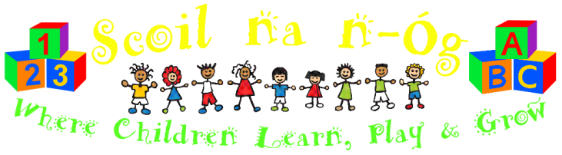
“Scoil na n-Óg” Montessori School, Proudstown Road, Navan, County Meath.
Tel: 046-9076288.
Record Keeping/Child and Family Details (Private and Confidential)
MONTESSORI APPLICATION FORM.
Child’s Name: _____________________________________________________________
Date of Birth: ____________________________________________________________
Home Address: ____________________________________________________________
Contact Telephone Number: __________________________________________________
Parents/Guardians Name: ____________________________________________________
Contact Number: __________________________________________________________
The Year you wish to enroll your child: __________________________________________
Morning or afternoon session: ________________________________________________
(We will try to accommodate your preference as best we can, but this may not always be possible depending on the time frame of the application).
These forms are used for application purposes only. When a place becomes available, an enrolment form will be sent to you offering your child a place. Should you decide to place your child with Scoil na n-Óg, please complete the forms, sign the necessary papers and return to Scoil na n-Óg together with the booking deposit to reserve a place for your child. Deposits are non-refundable should you later decline the place. Terms and conditions are available on request.
--------------------------------------------------------------------------------------------------------
Data Privacy: Consent for collection and usage of your personal data.
Scoil na n-Og Montessori School has a privacy notice which is available on request. We request this personal information about you and your child in order to process enrolments and allocate places. You have the right to request personal data we may hold about you. This is known as a Data Subject Access Request (‘DSAR’). A data subject is an individual who is the subject of the personal data. If you wish to make a DSAR, please complete this ‘DSAR’ form and return to us by post or email.
---------------------------------------------------------------------------------------------------------
I have read the above information and consent to my personal and my child’s personal information being collected by this service for the schools application process.
*Parent/Guardian Signature: ___________________________________Date:__________
*Parent/Guardian Signature: ___________________________________Date:__________

